# BAM Assignment Report

-MIT2019098 (Ratnesh Kumar Rai)

**Problem:** A Bidirectional Associative Memory (BAM) is required to store the following M =4 pairs of patterns:

Set A: X1 =[1 1 1 1 1 1 ]T, X2 =[-1 -1 -1 -1 -1 -1 ]T, X3 =[1 -1 -1 1 1 1 ]T,

X4 =[1 1 -1 -1 -1 -1 ]T

Set B: Y1=[1 1 1]T, Y2=[-1 -1 -1]T, Y3=[-1 1 1]T, Y4=[1 -1 1]T

Using BAM algorithm, train a W matrix for BAM which can retrieve all the above mentioned 4 pairs.

Hence test the level of weight corrections of the BAM with examples**.**

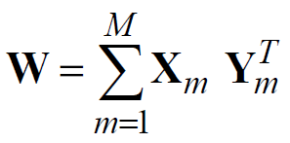**Solution:** For solving the above problem, we have implemented BAM network with 6 input neurons or nodes in 1st layer and 3 neuron or nodes in 2nd layer. Thus, we will have W (co-relation matrix) of dim 6x3 for forward association i.e. X->Y. Now, for backward association we are using V(co-relation matrix).

* Now, initially and V = WT
* We are using, the following Transmission function,
$f\left(x\right)=\left\{\begin{aligned}-1, &x<0 \\ 0, &x≥0\end{aligned}\right.$

* We are then applying the learning rule as:



* Learning rate(η) is set as 0.1.
* After 2 epochs, we obtained convergence.

Following are the Weight Matrices we are getting:

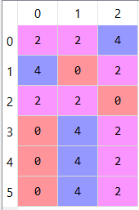

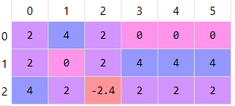

W = V =

**Observation:**

After testing we observed that for more than 2 error in X, implemented BAM is not able to converge to stable state.

|  |  |  |  |  |
| --- | --- | --- | --- | --- |
| X | | Y | | Result |
| Xinput | Ypred | Yinput | Xpred | Recognised |
| 1,1,-**1**,1,1,1 | 1,1,1 | -1,1,1 | 1, -1, -1, 1, 1, 1 | 100% |
| 1**,-1,**1,1,1,1 | 1,1,1 | -1,-1,1 | -1, -1, -1, -1, -1, -1 | 100% |
| **-1, -1**, 1, 1, 1, 1 | -1, 1, 1 | **-1**,1**,-1** | -1, -1, -1, 1, 1, 1 | 50% |

Note: Bold Text signifies error, red colour implies not a stable state.

Thus, we observed that for forward association correctness level is up to 2 error, but for backward association error tolerance is 0, for some cases it identified also up to 1 error but not always.

**Result:**

One of the reason for this error tolerance of backward association is because of the transmission function used, step function is not best suited for BAM, thus we can increase correctness level by modifying the transmission function.

**Thus, correctness level of calculated weight matrices are 2 errors for forward association and 1 error(max) for backward error.**